# Activity 3

## **Ex 3, p193**

*Your company recently announced a new benefit. According to the announcement, the company will “pay for expenses associated with taking job-related coursework or pursuing a program of study leading to a degree.” Courses must be approved by the employee’s manager prior to enrollment. A transcript and expense documentation must be submitted after the course ends. As a sales representative, you believe you would benefit from taking Comm 344 Persuasive Speaking at Ramsey College next semester. Prepare a message asking DuWayne Sussex, your manager, for approval to take the course. Classes begin in four weeks, and you would like to register as soon as possible.*

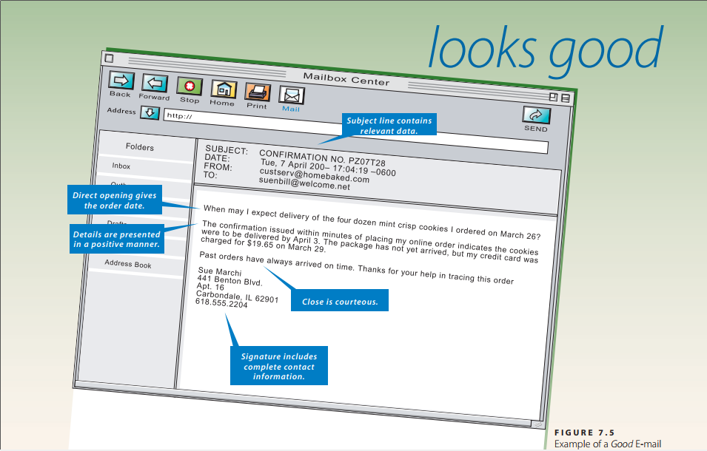

Message Type: Request for Information or Action

Dear Mr DuWayne Sussex,

I would like to get your approval for taking Comm 344 Persuasive Speaking at Ramsey College next semester.

According to new announcement, our company will pay expenses for employees taking job-related coursework or pursuing a program of study leading to a degree. As a sales representative, I believe this course from Ramsay College will greatly enhance my work productivity. Course enrollment enrolment requires the employee’s manager. I will provide transcript and expense documentation after the course ends*.* Classes will begin in four weeks.

I am looking forward to your approval soon. Thank you for your time and should you need further information, you can contact me any time.

Yours sincerely,

Hong Mien

## **Ex 4, p193**

*Technology. Refer to Case 3. Because your company’s educational benefit is new, you have several questions about what expenses are covered. Ideally, you would like the company to reimburse you for tuition, fees, books, meals, and—considering the cost of gas and your 80-mile round-trip commute—mileage. Prepare an e-mail to Renee Runk, HR Specialist, asking for more information.*

Message Type: Request for information

Dear Mrs Renee Runk,

I would like to know more about our company’s new education benefit.

Specifically, I am wondering what expenses will be covered in this benefit. Ideally, I would like the company to reimburse me for tuition fees, books. In addition, I am taking a 80-mile round-trip commute every day. Will it be included in the covered expenses?

I am looking forward to hearing from you. Thank you for your time.

Yours sincerely,

Hong Mien

Technology Department

## **Ex 8, p193**

***Technology. Global.*** *Dahui Lian, a Shanghai official with whom you have met on several past visits to China, is planning to come to the United States. Through your visits and subsequent e-mail exchanges, you have been successful in building a relationship with Dahui. Because of that relationship, he has asked for information about gratuity customs (tipping) in the United States. Use print and Internet resources to gather information about tipping in restaurants, airports, hotels, and other situations he might encounter. Write a message summarizing this information and e-mail it to him.*

Message Type: Social Business Message

Dear Lian:

Tipping is expected for many kinds of personal service in United States. Following are general rules of thumbs for tipping when you may need to keep in mind when you go to United States.

If you enjoy a sit-down meal, or drinks at a bar or lounge, expect to tip. If you request anything delivered to you (from a restaurant or room service), expect to tip. If you take a car service, taxi, or ride share, expect to tip.

If you receive assistance with luggage at a hotel or at the airport, expect to tip a few dollars. If you take a formalized tour, expect to tip. If you use any spa, hail, or nail services, expect to tip. If you are staying at a hotel, expect to tip housekeeping.

However, if you are picking up an order, just receive the kindness of a stranger, or take public transportation, do not expect to tip. Similarly, you generally do not tip if you get fast food or you are at a restaurant with self-service.

I hope this information are helpful to you and hope you will have an enjoyable trip in the United States.

Sincerely,

Hong Mien

LA, United States

## **Ex 20, p195**

*Dan Daily, purchasing manager for the ValueMax supermarket chain, has requested a 10 percent discount on the cost of the 25,000-unit shipment of paper grocery bags delivered to his warehouse last week. The samples he sent support his claim that the logo color is faint and both it and the store name are noticeably off center. You agree. Prepare a letter that approves his claim and retains him as a customer.*

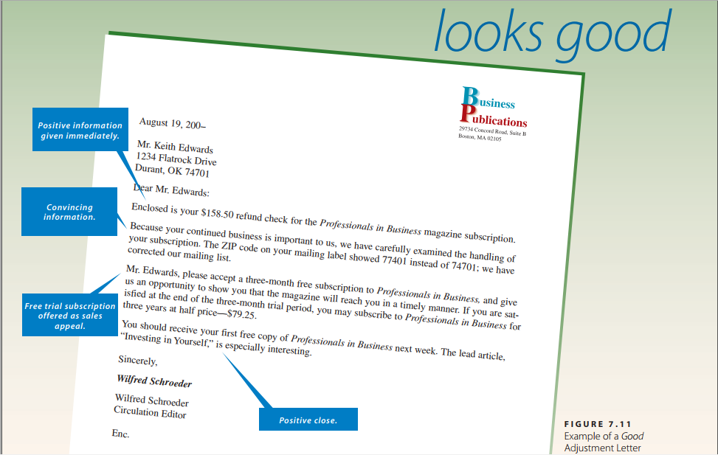

Message Type: Claim adjustment letter

Dear Mr. Daily:

Enclosed is your $150, equivalent to 10% discount of the cost of the 25,000-unit shipment of paper grocery bags delivered to your warehouse last week.

Because your continued business is important to us, we have carefully examined the handling of your package. We found out due to heavy rain there were problems with the logo color and store name during the shipping process.

Mr Daily, please our free shipping for one next order of yours within 10 kilometers. We will do our best to improve your services and hope to maintain long-term relationships with you.

Sincerely,

Hong Mien

Head of ValueMax Marketing Department

## **Ex 30, p195**

*Welcome. You are the president of the Tri-City Industrial Foundation. You have been successful in getting Little Toy Machines, a toy manufacturer, to relocate to your community. This factory will provide employment for 325 people. Write a letter to the president, Roy Stevens, welcoming him and his company.*

Message Type: Social Business Message - Welcome

Dear Roy:  
Welcome to Tri-City, the community of emerging industrial development! We are excited to have you here with us to promote mutual economic development of your company and our city.  
The first few months will be both reaffirming and challenging. As the local residents may not be familiar to your products, it will take time for you to get familiar to the surroundings as well as attract new customers. In addition, the training process for new local employees requires time and efforts as well.

You will not make this journey alone, Roy. You will have us here as friends and consultants to support you with marketing or recruitment, just feel free to contact me anytime. You are part of the Tri-City now . . . come and grow with us!

Sincerely,

Hong Mien

President of the Tri-City Industrial Foundation